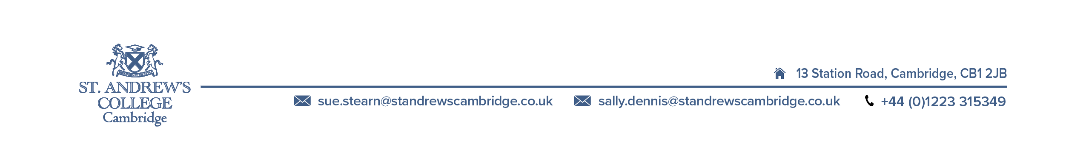

STUDENT INVOICE

Miss E ROCHETTI
Invoice Number: | 82245
Date: | 24/09/2018
Student Number: | 28782
Agent Code: | JACKNJILL
Invoice Destination: | Student
Page: | 1

 | Miss Emma ROCHETTI | Select English Ltd

Description | From | To | Wks | Value
English 32 lessons (24 hrs)  Homestay accom academic year (single) | 22/10/2018  21/10/2018 | 26/10/2018  27/10/2018 | 1/0  0/6 | 190.00  165.00
Total Value | £ 355.00

Balance of fees is due 4 weeks before the start of the course, or immediately if registering within
this period. If you are sending fees by direct bank transfer please note that the remitter must pay
all bank charges. To aid in the identification of payment please make sure that the student's name
and student's number is stated on all transfer documents. THANK YOU

Please pay fees in English pounds:
Online payment (card or bank transfer): https://merchant.pay-ed.com/payment/select
Or direct payment to Lloyds Bank, 3 Sidney Street, Cambridge, CB2 3HQ, England
Sort Code: 30-91-56 Account number: 01808167 Account name: Select English Ltd
IBAN: GB84 LOYD 3091 5601 8081 67
BIC: LOYDGB21018 SWIFT: LOYDGB2L

If you paid your deposit by credit card, the balance of your fees will automatically be taken from that card when they are due, unless you instruct us otherwise.

